**Assignment 6**

**A) Create emp table with Appropriate Data types, insert data into the table**

|  |  |  |  |  |  |
| --- | --- | --- | --- | --- | --- |
| **Empid** | **EmpName** | **Department** | **ContactNo** | **EmailId** | **EmpHeadId** |
| **101** | **Isha** | **E-101** | **1234567890** | [**isha@gmail.com**](mailto:isha@gmail.com) | **105** |
| **102** | **Priya** | **E-104** | **1234567890** | [**priya@yahoo.com**](mailto:priya@yahoo.com) | **103** |
| **103** | **Neha** | **E-101** | **1234567890** | [**neha@gmail.com**](mailto:neha@gmail.com) | **101** |
| **104** | **Rahul** | **E-102** | **1234567890** | [**rahul@yahoo.com**](mailto:rahul@yahoo.com) | **105** |
| **105** | **Abhishek** | **E-101** | **1234567890** | [**abhishek@gmail.com**](mailto:abhishek@gmail.com) | **102** |

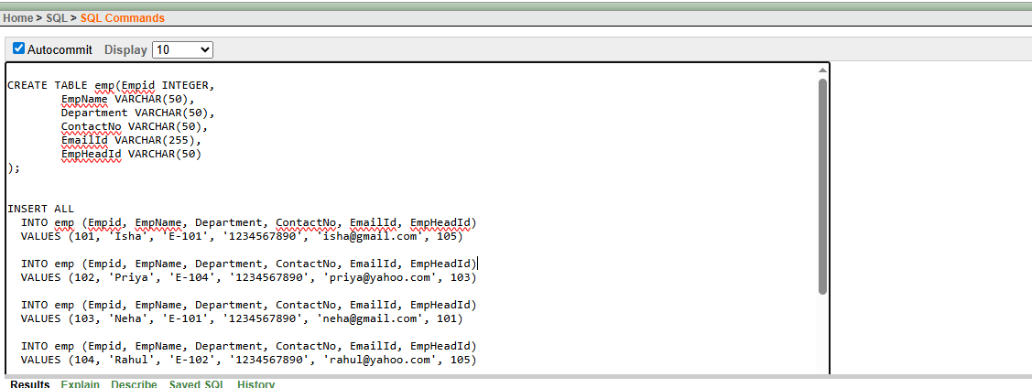

**1. Update department value as E-111 for the EmpHeadId is 105.**

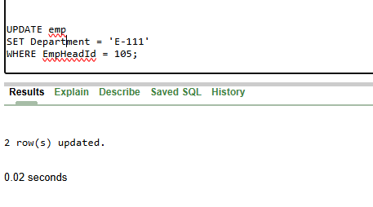

**2. Update email ID to** [**ts123comp@gmail.com**](mailto:ts123comp@gmail.com) **for Abhishek.**

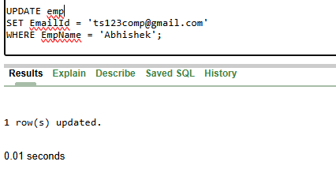

**3. Delete the record for Department E-104.**

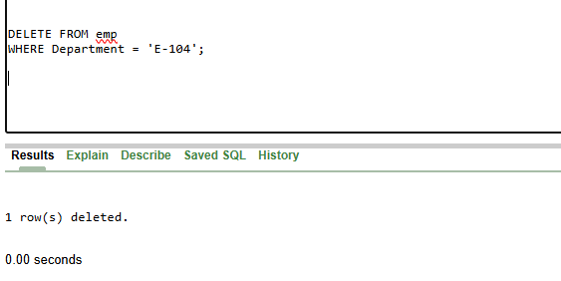

**4. Add column City to the emp table.**

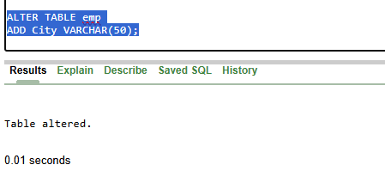

**5. Drop EmpHeadId column from emp table.**

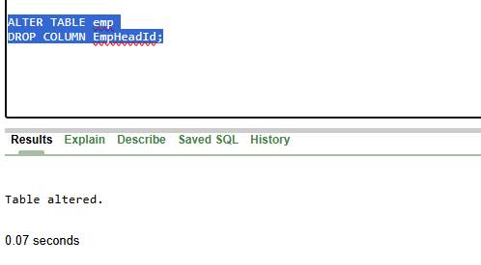

**6. Rename emp as employees**

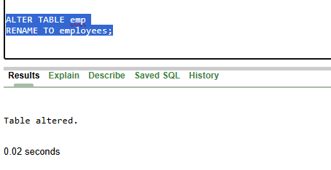

**7. Truncate table employees**

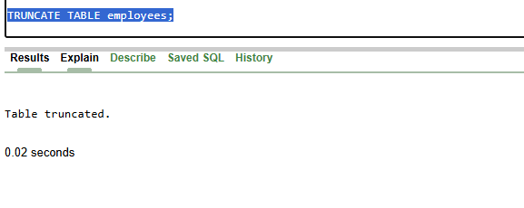

**8. Drop table employees**

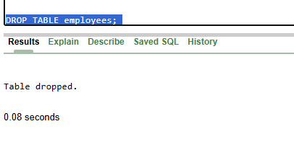

**B) Create table customer with appropriate Data types and Insert following Data**



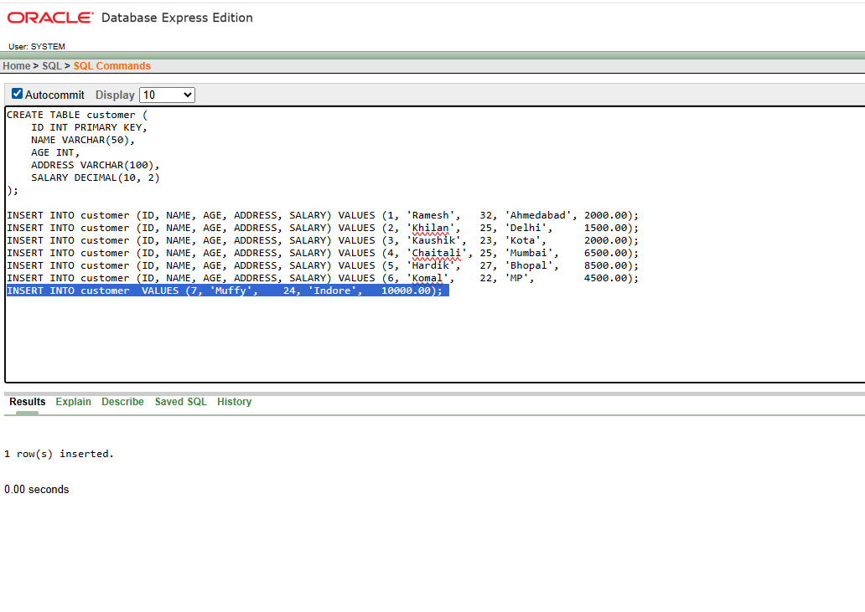

**1. Display ID, Name and Salary of all the employees.**

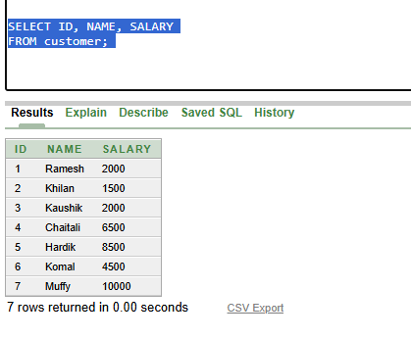

**2. Change salary of Ramesh to 15000 rupees**

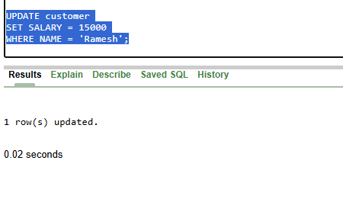

**3. Change age of muffy to 32 years**

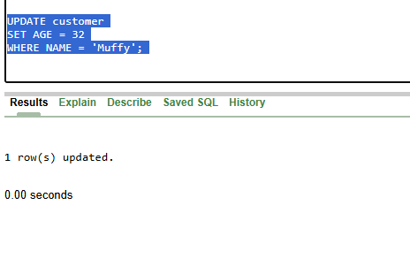

**4. Add column city.**

